Extra 21-1 Send an email from the Halloween Store application

In this exercise, you’ll send an email from the Halloween Store application that confirms a customer’s order.

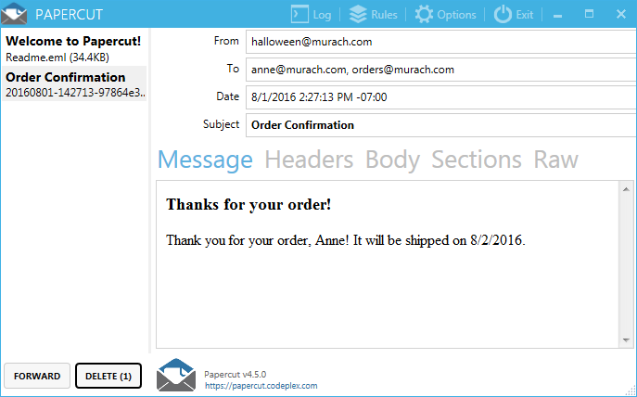

Install or open the Papercut SMTP server

1. If you don’t already have Papercut on your computer, follow the instructions in figure 21-2 to download and install it. Otherwise, open or display the Papercut application.

Create and send a plain text email message

1. Open the XEx21SendEmail application in your exercises_extra directory, and display the code-behind file for the Confirmation page.
2. **Confirmation.aspx.cs** - Code a private method for sending an email confirmation that doesn’t return a value, and that accepts a Customer object and a string as parameters.
3. This method should create a mail message with the from address “Halloween@murach.com”, the from name “Halloween Store, and the subject “Order confirmation”.
4. Use the EmailAddress property of the Customer object for the to address, and the string that’s passed to the method for the body.
5. Add another to address to the message so it will also be sent to “orders@murach.com”. Then, add code to send the email using the localhost server.
6. Add a statement to the Page_Load event handler that calls the method you just added. Pass the customer object that the Load event handler uses to the method, along with the same string that’s used to set the Text property of the confirm label on the page.
7. Run the application and place an order. When you do, the Papercut window should display the confirmation email.
8. Click on the Headers, Body, Sections, and Raw tabs to view the email and then go back to the Message tab. When you’re done, delete the email and then click the close button to minimize the Papercut window.
9. Go back to the application and place another order. This time, you may see an email notification in the system tray. If you do, click on the notification to display the email message in Papercut. Otherwise, click the up arrow in the lower right corner of the task bar and then click the Papercut icon to display the message. When you’re done, delete the message and minimize Papercut again.

Add an HTML email message

1. Add an alternate view to the mail message to include the message in HTML format as well as text format. The head element for this message should contain a title element with the value “Order confirmation”. The body element should contain an h3 element that says “Thanks for your order!” and a <p> element with the value of the string that’s passed to the method.
2. Run the application and place an order. This time when you display Papercut, the email should be formatted as shown above.
3. Repeat step 7 to review the multipart email. Pay particular attention to how the email looks in the Sections and Raw tabs. When you’re done, delete the email and then click the Exit button to close Papercut.